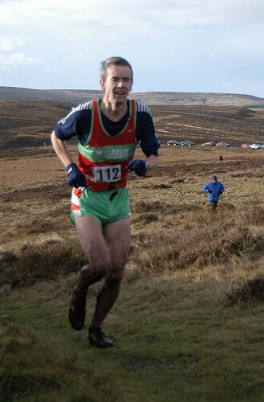
ILKLEY HARRIERS PRESENTS
A NAVIGATIONAL SKILLS DAY
…ever got lost on the moors?
…want to try fell running but not sure?
…want to win the Jack Bloor?
…want to be able to read a map?
…wish you had more fell confidence?
…want to learn from the best?
…don’t be a follower, be a LEADER!

SATURDAY 2nd DECEMBER

9:00am at DARWIN GARDENS (top of Wells Road)

All abilities welcome

PLEASE HAVE FULL BODY COVER (As you would for a long fell race, so waterproof top, bottoms, hat, gloves and whistle), a MAP and a COMPASS

Please bring a flask of tea and warm clothes for between sessions

RSVP to Graham Pearce on 07768 326 567, or graham.pearce@kpmg.co.uk.

